Analysis of  
Buy a car

Table of contents

Summary

**BMW** is the best alternative, but not with a large margin.  
There are no big differences between the alternatives.  
No criterion is dominating the solution.  
All criteria contribute to the solution.

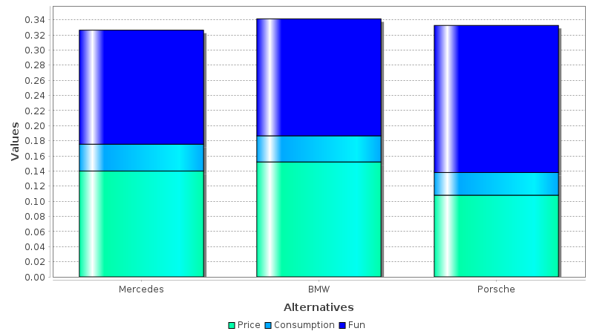

Overview

This report considers the task  
**Buy a car**

* The task proposes a number of **3** alternatives.
  + **BMW**Rating: *0.341230*
  + **Porsche**Rating: *0.332526*
  + **Mercedes**Rating: *0.326244*
* A number of **4** criteria is considered for evaluation.
  + **Price** [Euro]  
    *The costs to buy the car*Weight: *0.400000*  
    Has the highest weight and is most important.
  + **Speed** [km/h]  
    *The maximum speed the car is capable of*Weight: *0.300000*  
    Is close to most important.
  + **Sound** [dB]  
    *The loudness of the car*Weight: *0.200000*  
    Is around **1/2** important as the most important criteria.
  + **Consumption** [l/100km]  
    *The consumption of fuel*Weight: *0.100000*  
    Is around **1/4** important as the most important criteria.
* The criteria are arranged in **2** groups.
  + **Buy a car**Weight: *1.00000*  
    Contains groups: *Fun*  
    Contains criteria: *Price, Consumption*
  + **Fun**Weight: *0.500000*  
    Contains criteria: *Speed, Sound*
* Some criteria seem to be correlated.

Stability

Changing the weights of any criterion by **10**% does not change the ranking of alternatives.

Changing the weights of the following criteria by **50**% changes the ranking of alternatives:

* **Price** - best alternative not affected

Correlation

The following criteria seem correlated:

* **Price** with *Sound*
* **Speed** with *Consumption*
* **Consumption** with *Speed*
* **Sound** with *Price*

Distribution

The following values were given in probability distributions

|  |  |  |
| --- | --- | --- |
| Criterion | Alternative | Distribution |
| Price | Porsche | Triangular Distribution min=60000.0 max=90000.0 mode=80000.0 |

Ensemble

Ensemble was calculated with **1000** sample counts.  
For the defined distribution functions, the following ensemble values result:

* **BMW**  
  Mean: 0.341144  
  Std. Deviation: 0.00181626  
  Min: 0.336112  
  Max: 0.344606  
  Ranking: 891.0, 0.0, 0.0
* **Porsche**  
  Mean: 0.332719  
  Std. Deviation: 0.00408660  
  Min: 0.324929  
  Max: 0.344041  
  Ranking: 109.0, 0.0, 0.0
* **Mercedes**  
  Mean: 0.326137  
  Std. Deviation: 0.00227033  
  Min: 0.319847  
  Max: 0.330465  
  Ranking: 0.0, 0.0, 0.0